PROJECT -7
NEWS READ AGENT
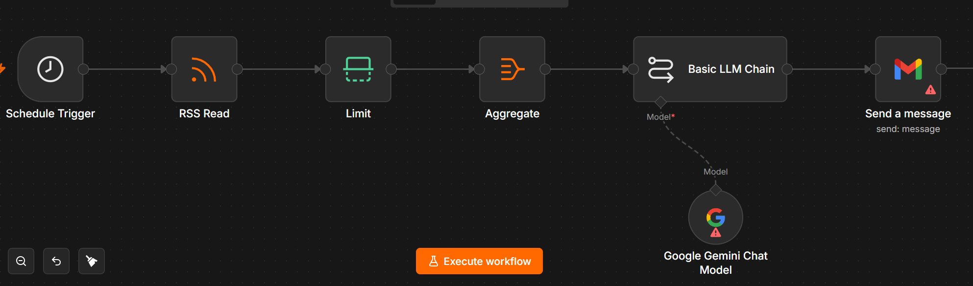
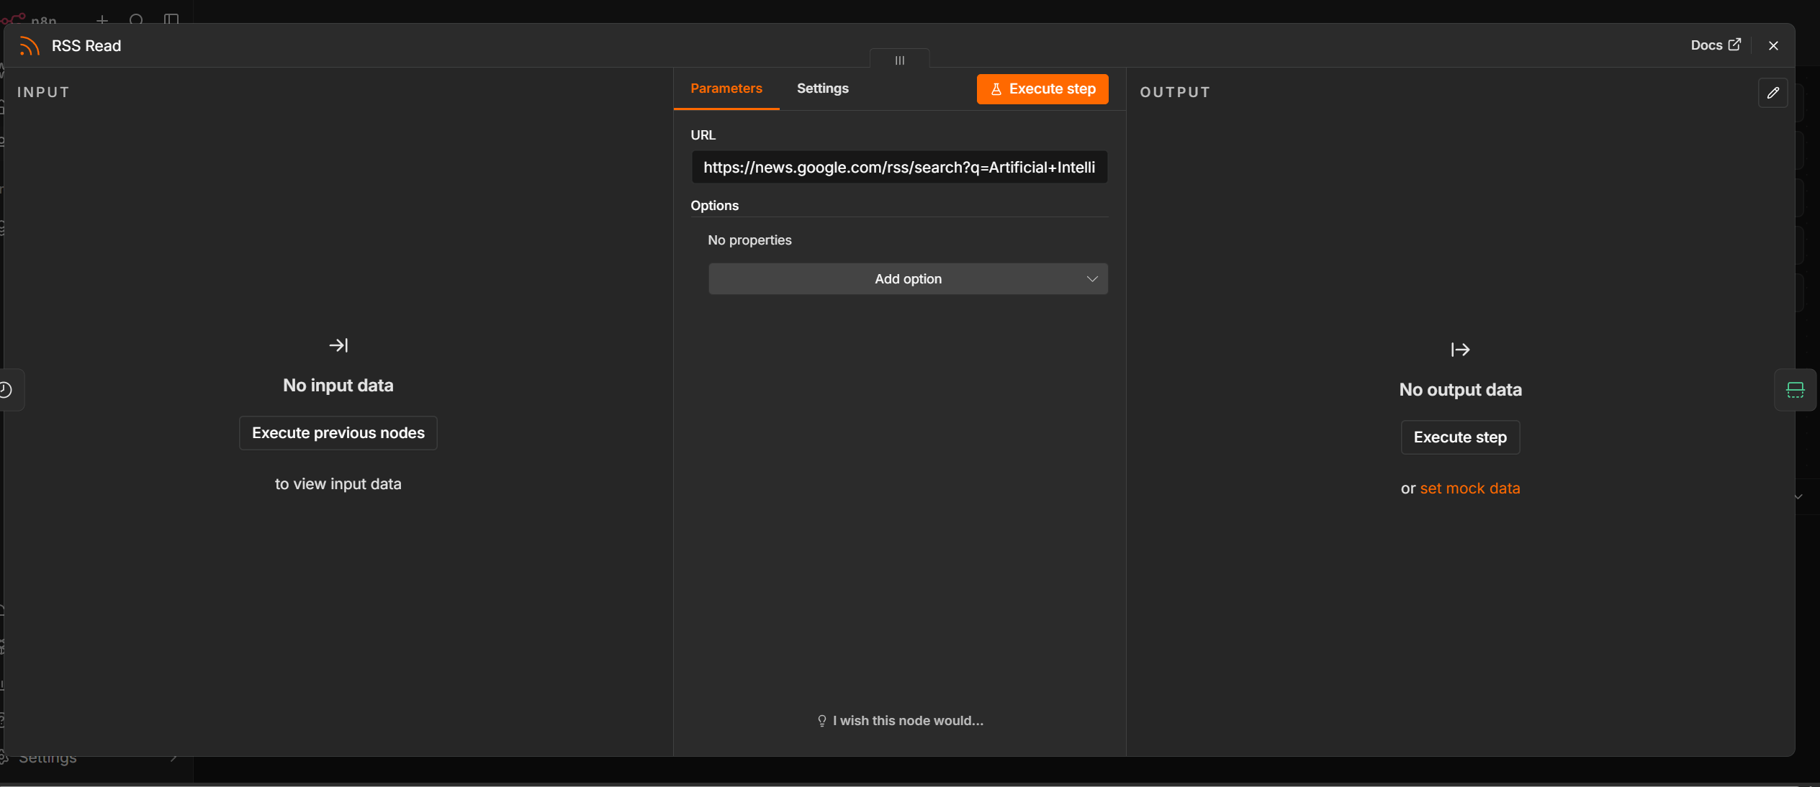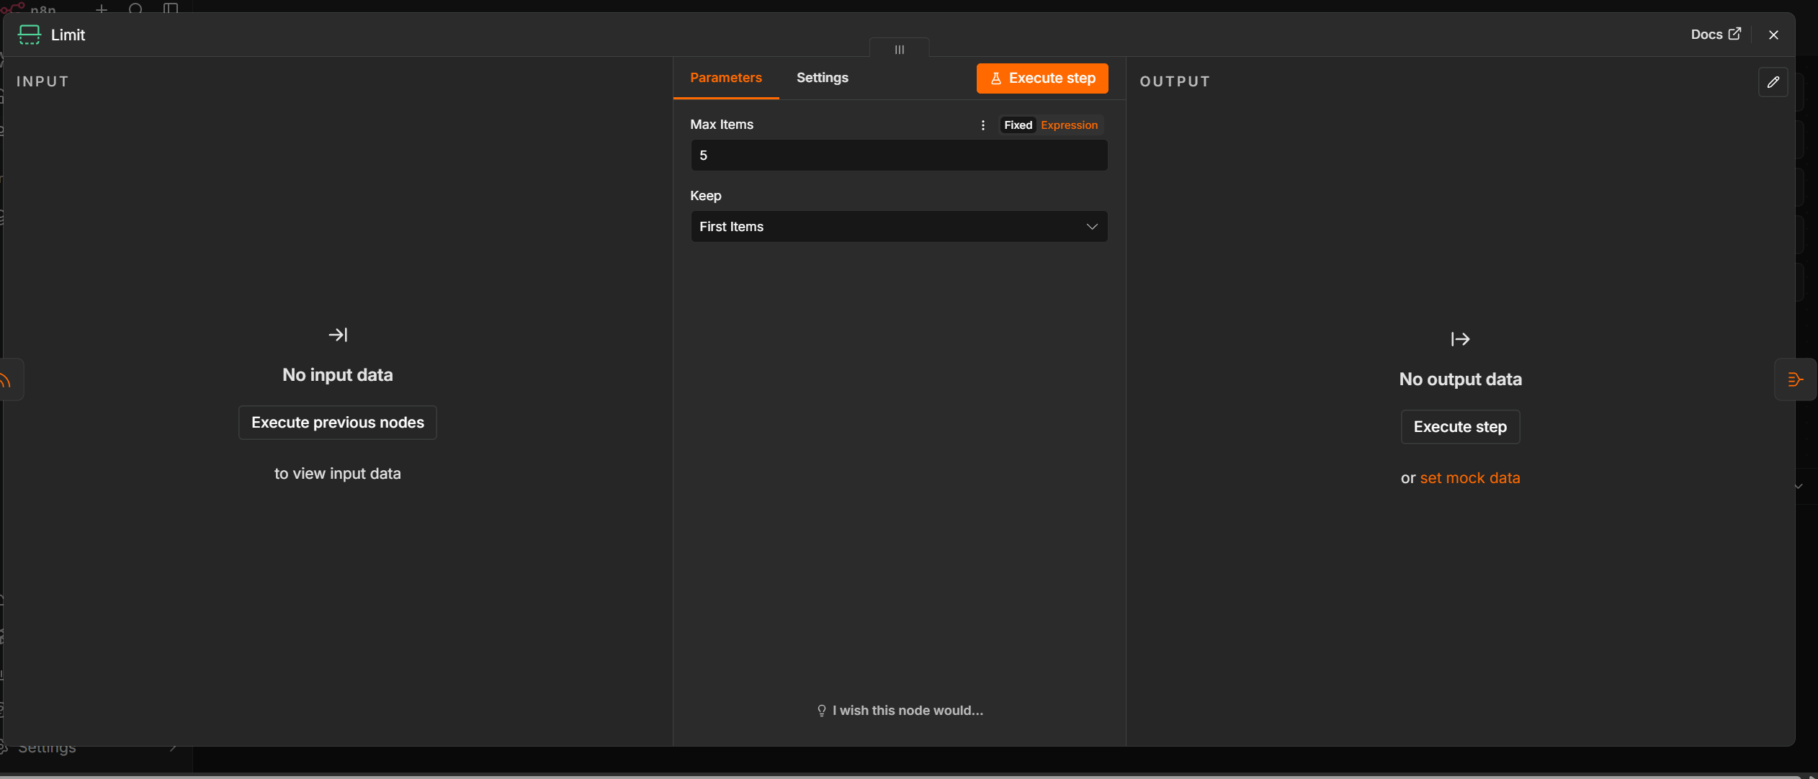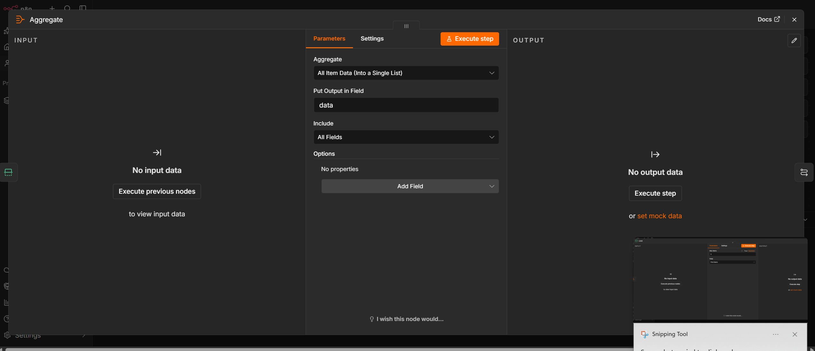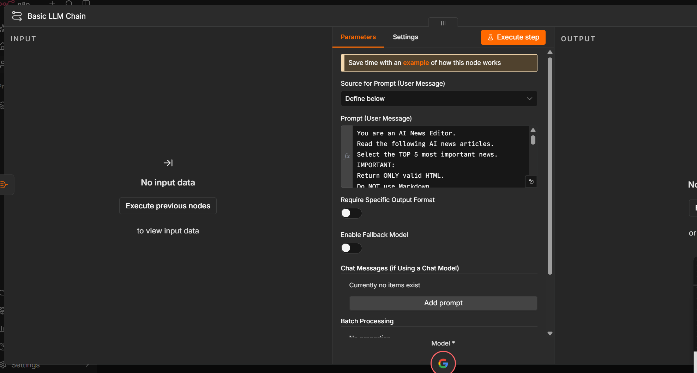
RSS LINK : https://news.google.com/rss/search?q=Artificial+Intelligence
RSS News Summarization Workflow Documentation
Workflow Overview
This workflow automatically reads articles from an RSS feed, summarizes them using a Large Language Model (Google Gemini), and emails the summary using Gmail.
Workflow Steps
1. Schedule Trigger
Starts the workflow automatically at the configured time or interval.
2. Really Simple Syndication(RSS Read)
Fetches the latest articles from the configured RSS feed.
3. Limit
Restricts the number of RSS items processed in a single execution.
4. Aggregate
Combines the selected RSS items into one text block before sending to the LLM.
5. Basic LLM Chain
Sends the aggregated content to the Google Gemini Chat Model with a prompt to summarize or analyze the news.
6. Google Gemini Chat Model
Processes the prompt and returns the AI-generated summary.
7. Gmail – Send a Message
Emails the generated summary to the configured recipient(s).
Workflow Flow
Schedule Trigger → RSS Read → Limit → Aggregate → Basic LLM Chain (Google Gemini) → Gmail
Input
- RSS Feed URL
- Execution Schedule
- Gemini API credentials
- Gmail account credentials
Output
An email containing the AI-generated summary of the latest RSS articles.
Use Cases
- Daily technology news digest
- Company or competitor monitoring
- Research updates
- Blog/newsletter automation

